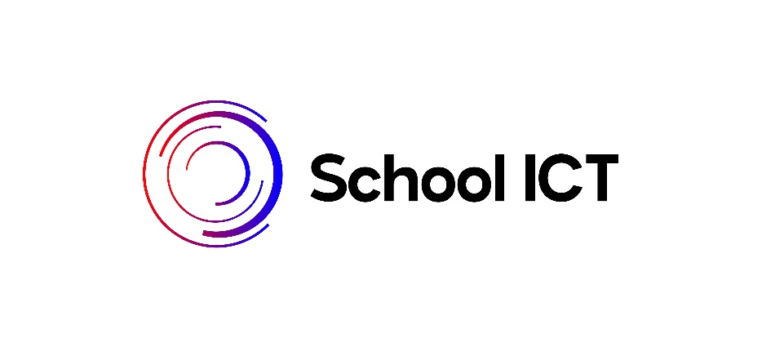

Customer Portal

Welcome to Schools ICT. As a customer you have access to resources via a customer portal which is accessed via https://my.schoolicts.co.uk/
This is the main source of information and access to our latest training courses, remote support and guidance notes and features.
To access the portal, you will need a unique log in. If you have not yet received please contact the Helpdesk at helpdesk@schoolicts.co.uk or 0345 2226802.
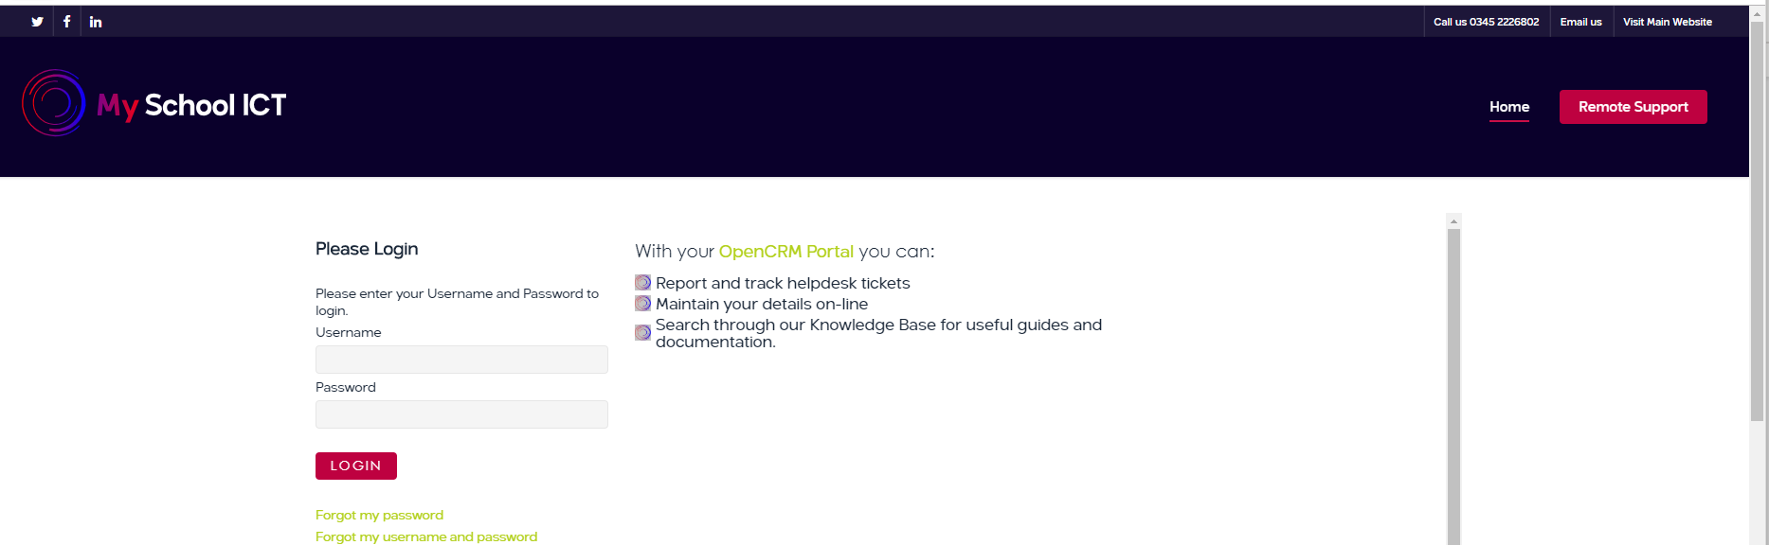
Once you have logged in you can access the main documentation via Knowledgebase
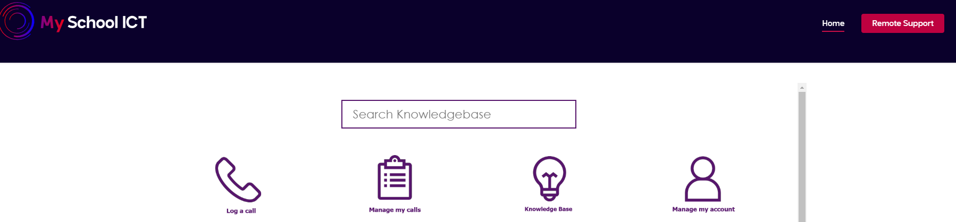
Then Categories
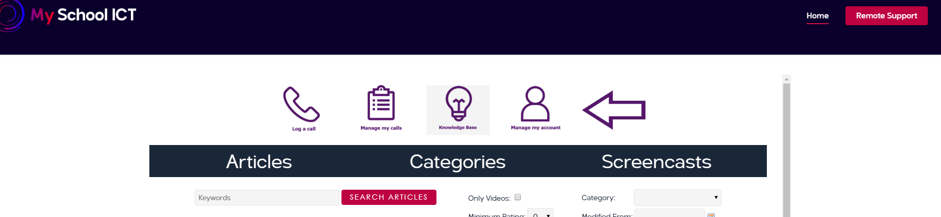

User guides and notes can then be found in the Subject Category

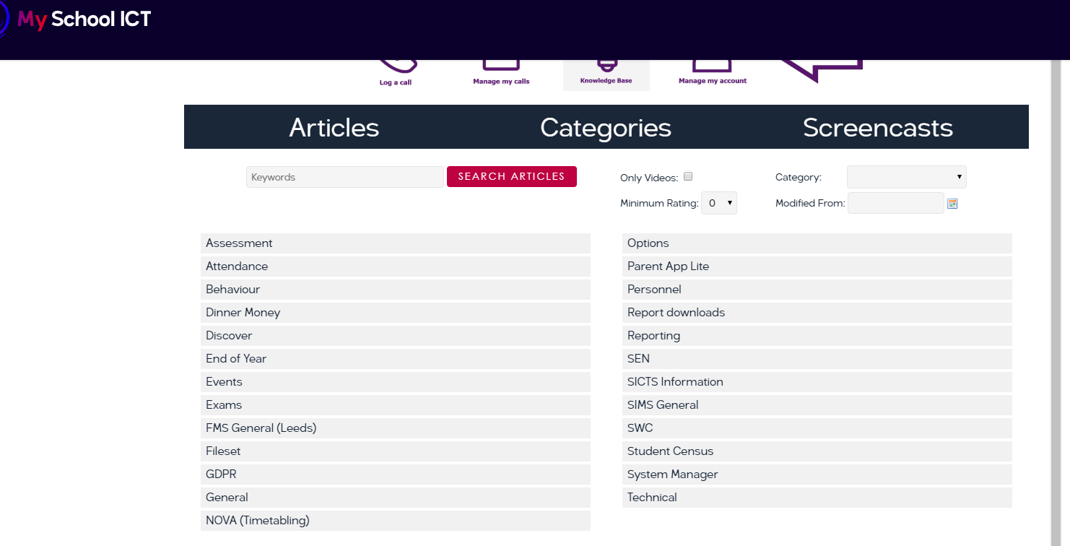
In addition, you can also log a query with the Helpdesk via Log a Call
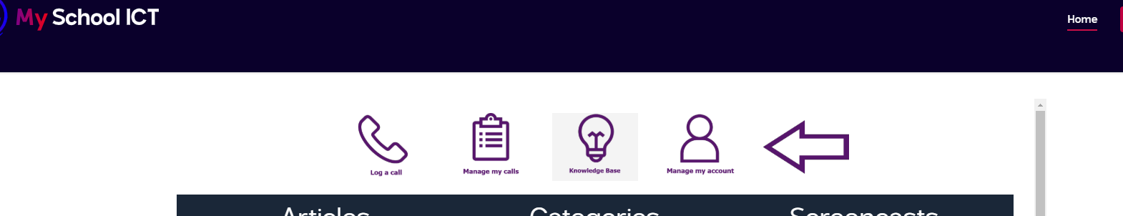
Enter the details and submit.
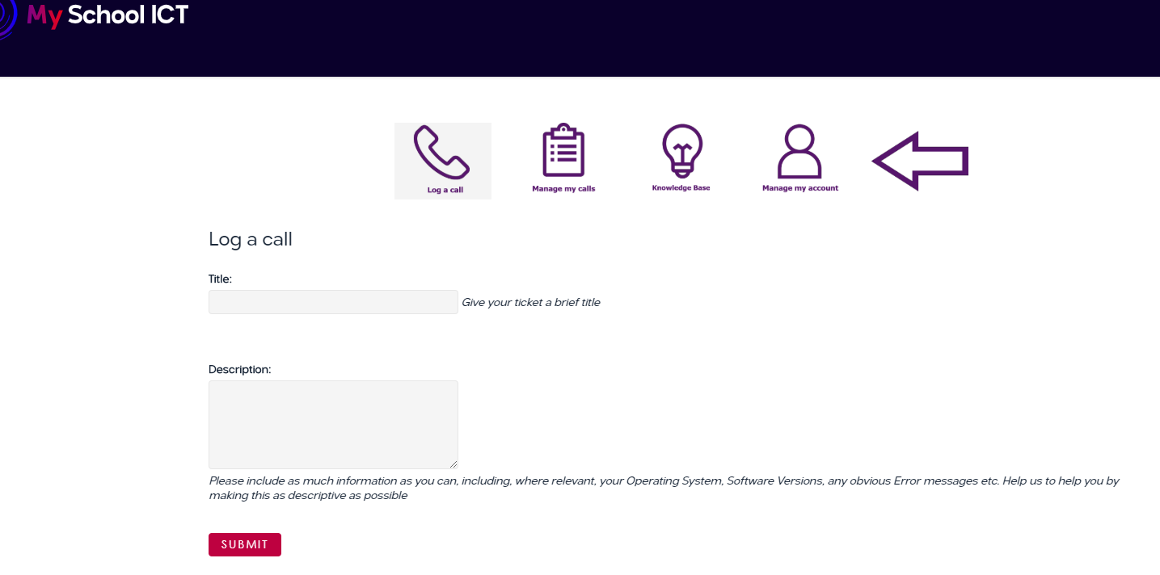
You will then receive an acknowledgement and ticket number from the Helpdesk and a response.

If you want to check the progress of your call, then you can check this via Manage my calls
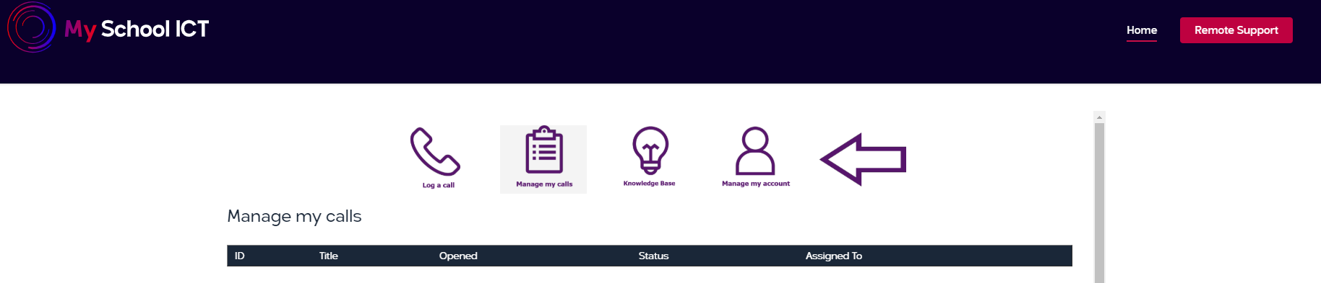

On occasion we may need to remote onto your computer to talk through a solution or to explain how to complete a function in SIMS. This is accessed via the Remote Support link on the website.
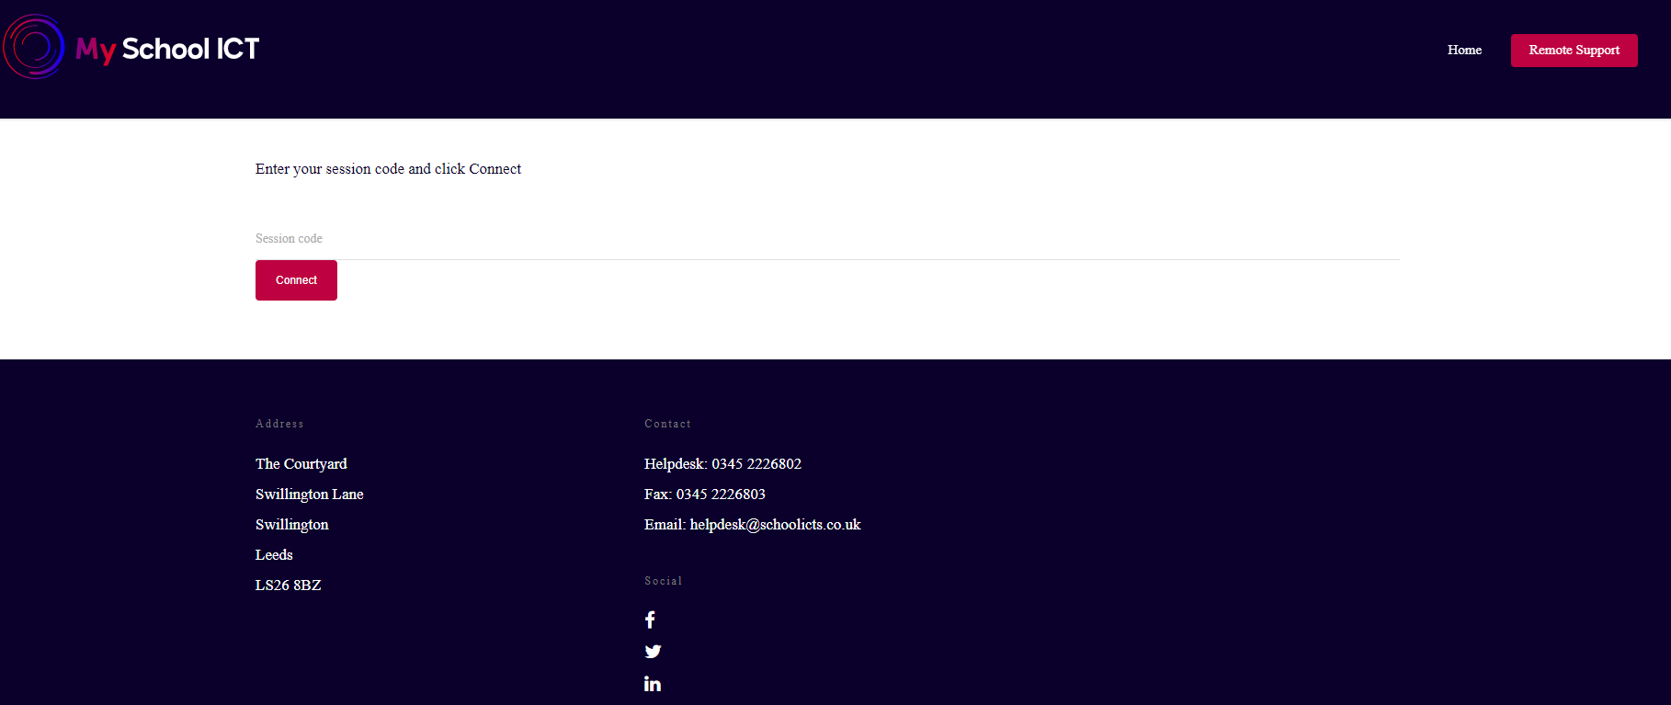
You will be given a code to enter which will then launch the ISL Client which is what we use to connect to your machine.

