

How to download and apply a new census fileset

To import a revised fileset you must be a member of any of the following user groups in system manager:
- Personnel Officer
- Returns Manager
- System Manager
- Log onto the Customer Portal at https://my.schoolicts.co.uk/
- Navigate to Knowledge Base/ Categories /Fileset and locate the fileset.
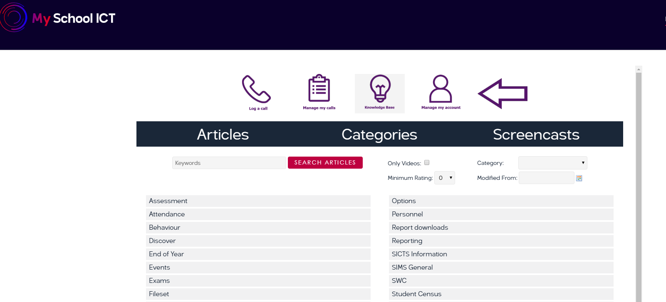

- Click on the Fileset to download. It will be a zipped file.
- Save the Zipped file on your workstation in a folder that you can easily find.
- Unzip the file by right clicking and choosing extract all.
- In Sims choose Tools – Setups - Import Fileset to display the Import Fileset page.

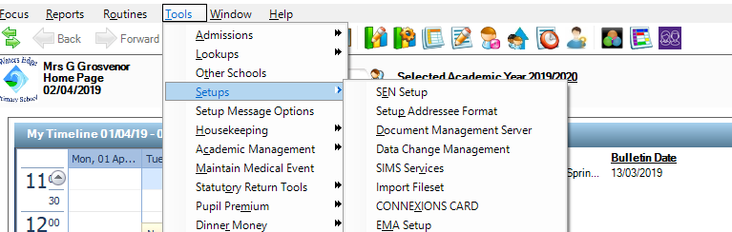

- Click the Browse button to display the Open dialogue.
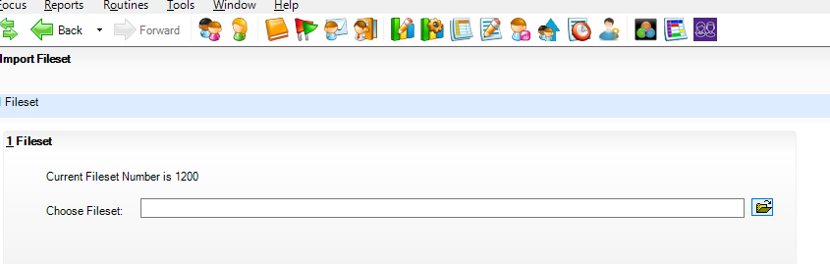
- 6. Navigate to the location of the downloaded Fileset.
- Highlight the file then click the open button. Alternatively, double-click the required MFS file to return to the import Fileset page.
- Details of the selected Fileset are displayed including the version number of the Fileset, the release date and the Fileset description.
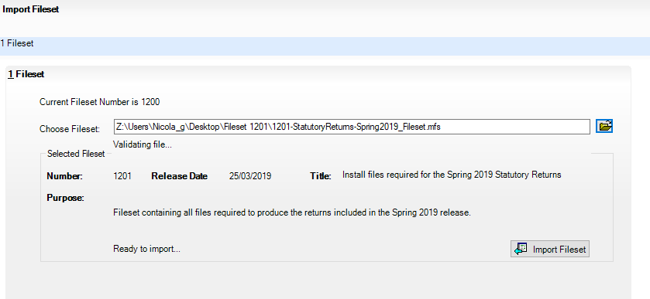

- Click the Import Fileset button to import the Fileset into Sims. When the import is finished, Import successful is displayed in the bottom left-hand side of the Fileset panel and you will be advised to restart Sims. This ensures that the newly imported data will take effect.
- Click the Ok button.
- Close down SIMS and then reopen.
- When you go to run a new census via Routines – Statutory Return – School Census on the top line you will see Census Return for Term Year (Fileset ID ???) The new Fileset number should be there. If you require any further assistance call 0345 2226802

