Dear Colleague
Could I please draw your attention to the following important school census information this is based on current guidance. If there is additional information, we will make customers aware via email as well as updating the news section on our website https://www.schoolicts.co.uk/latest-news/
The Dry run will become available via School | Data | Export | Data Returns and School Census on Thursday 4th May.

How has the School census return changed?

Census Date: Thursday 18th May 2023
Census Date 18/05/23
Item | Date From | Date to
Attendance | 01/01/23 | 09/04/23
Exclusions | 01/08/22 | 09/04/23
Free School Meals | 20/01/23 | 18/05/23
National Tutoring Programme (Funding and Monitoring) | 01/08/22 | 18/05/23
Leavers with attendance | 01/01/23 | 09/04/23
Leavers with exclusions | 01/08/22 | 09/04/23
Leaver with funding and monitoring | 01/08/22 | 18/05/23
Leaver with alternative provision | 19/01/23 | 17/05/23

Deadline for return:
DfE deadline is Wednesday 14th June 2023 however your Local Authority may have a shorter deadline if you submit to them rather than COLLECT- please contact them for further details.

New Data items:
There are no added items introduced in this return.

Accessing the Return
School/Data/Export/Data Return
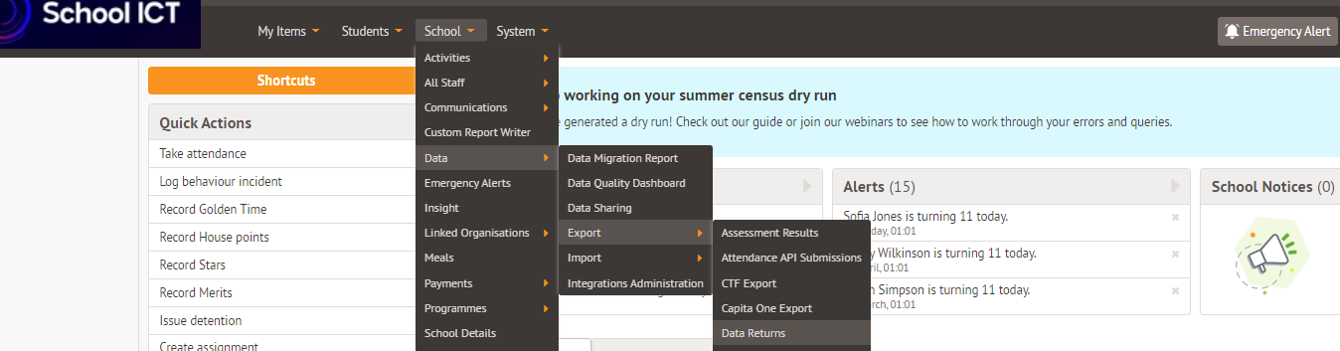

Documentations to assist with completing the return:
We have uploaded the guidance for completing the return on the customer portal. Please see the links below to download. These includes a checklist to assist with preparing the data for collection to minimise validation errors.
Secondary Guidance:- https://my.schoolicts.co.uk/portal/kb?id=537
Primary Guidance:- https://my.schoolicts.co.uk/portal/kb?id=623
Guidance on Dates of birth and Curriculum Years https://my.schoolicts.co.uk/portal/kb?id=294

Known Issues:
On the day errors and queries: https://support.arbor-education.com/hc/en-us/sections/4404257516957-On-the-day-errors-and-queries

Data Items included in this return; - full details of what is included in each return can be found via DfE spreadsheet
https://www.gov.uk/guidance/complete-the-school-census/data-items-2022-to-2023

Data items 2022 to 2023

Guidance about every piece of information you need to send us in autumn 2022, spring and summer 2023.
You can also download a spreadsheet of all the information we ask for (ODS, 16KB).

Training
All of our scheduled training courses have now taken place but if you would like to contact us to add your name to our waiting list, we can run an additional course if there is enough interest.

Please remember that our helpdesk will be open from 08:00 until 17:00 so please do not hesitate to contact if you require further assistance.

